EXPERIMENT – 03

Implementation of Conditional Logic using IF–ELSE and CASE Statements in PostgreSQL

Aim
To implement conditional decision-making logic in PostgreSQL using IF–ELSE constructs and CASE expressions for classification, validation, and rule-based data processing.

Tools Used
- PostgreSQL

Objectives
- To understand conditional execution in SQL
- To implement decision-making logic using CASE expressions

- To simulate real-world rule validation scenarios
- To classify data based on multiple conditions
- To strengthen SQL logic skills required in interviews and backend systems

Experiment / Practical Steps

Prerequisite Understanding
Students should first create a table that stores:
- A unique identifier
- A schema or entity name
- A numeric count representing violations or issues
Populate the table with multiple records having different violation counts.

Step 1: Classifying Data Using CASE Expression
create table schema_Analysis
(
id int primary key,
schema_name varchar(50),
violation_score int
)

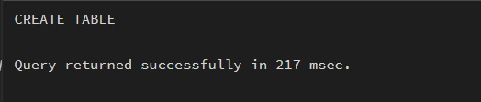

insert into schema_Analysis values(1,'dept_table',2),
(2,'log_table',4),
(3,'emp_table',0),
(4,'project_table',1),
(5,'user_table',1),
(6,'student_table',3)

select* from schema_Analysis

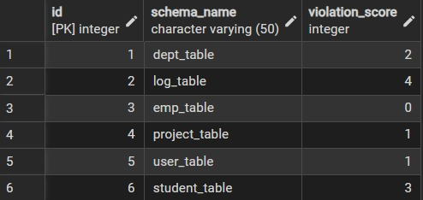

ALTER TABLE schema_analysis
ADD COLUMN violation_type VARCHAR(30);

UPDATE schema_Analysis
SET violation_type =
CASE
WHEN violation_score = 0 THEN 'NO VIOLATION'
WHEN violation_score BETWEEN 1 AND 2 THEN 'Minor Violation'
WHEN violation_score BETWEEN 3 AND 4 THEN 'Moderate Violation'
ELSE 'Critical Violation'
END;

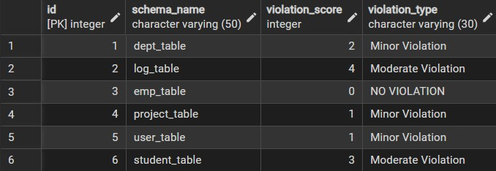

Step 2: Applying CASE Logic in Data Updates
ALTER TABLE schema_analysis
ADD COLUMN status VARCHAR(30);

UPDATE schema_Analysis
SET status =
CASE
WHEN violation_score = 0 THEN 'Approved'
WHEN violation_score BETWEEN 1 AND 2 THEN 'Needs Review'
ELSE 'Rejected'
END;
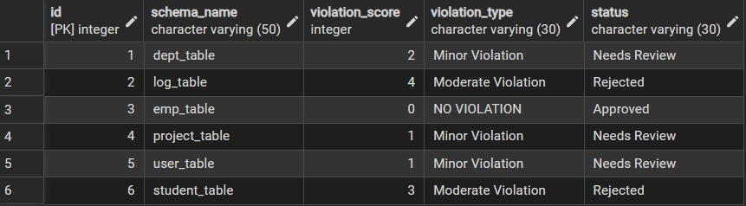

Step 3: Implementing IF–ELSE Logic Using PL/pgSQL
DO $$
DECLARE
violation_count INT := 3;
BEGIN
IF violation_count = 0 THEN
RAISE NOTICE 'NO VIOLATION';
ELSIF violation_count BETWEEN 1 AND 2 THEN
RAISE NOTICE 'Minor Violation';
ELSIF violation_count BETWEEN 3 AND 4 THEN
RAISE NOTICE 'Moderate Violation';
ELSE
RAISE NOTICE 'Critical Violation';
END IF;
END $$;
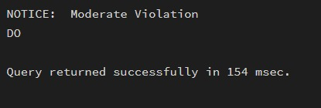

Step 4: Real-World Classification Scenario (Grading System)
create table student (
id int primary key ,
name varchar(50),
marks int
)

INSERT INTO student (id, name, marks) VALUES
(1, 'Amit', 85),
(2, 'Neha', 72),
(3, 'Rohan', 90),
(4, 'Simran', 65),
(5, 'Ankit', 40);

select * from student;

ALTER TABLE student
ADD COLUMN grade VARCHAR(2);

DO $$
DECLARE
r RECORD;
BEGIN
FOR r IN SELECT id, marks FROM student
LOOP
IF r.marks >= 90 THEN
UPDATE student SET grade = 'A' WHERE id = r.id;
ELSIF r.marks >= 75 THEN
UPDATE student SET grade = 'B' WHERE id = r.id;
ELSIF r.marks >= 50 THEN
UPDATE student SET grade = 'C' WHERE id = r.id;
ELSE
UPDATE student SET grade = 'F' WHERE id = r.id;
END IF;
END LOOP;
END $$;

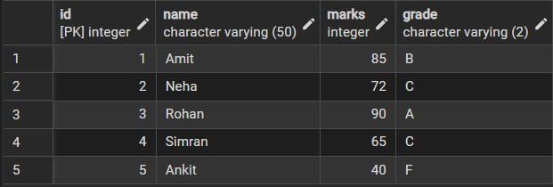

Step 5: Using CASE for Custom Sorting
SELECT
schema_name,
violation_score,
violation_type
FROM schema_Analysis
ORDER BY
CASE
WHEN violation_type = 'Critical Violation' THEN 1
WHEN violation_type = 'Moderate Violation' THEN 2
WHEN violation_type = 'Minor Violation' THEN 3
ELSE 4
END,schema_name;
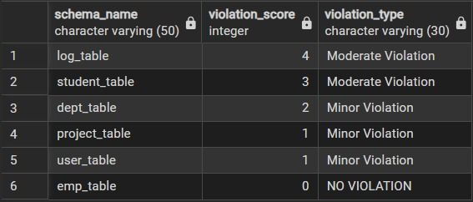

Course Outcome
This experiment demonstrates how conditional logic is implemented in PostgreSQL using CASE expressions and IF–ELSE constructs.
Students gain strong command over rule-based SQL logic, which is essential for:
- Backend systems
- Analytics
- Compliance reporting
- Placement and technical interviews

